**TOUR MANAGEMENT SYSTEM**

**A CASE STUDY OF AFRICA**

**MUTISYA GERRALD MUTUA**

**BIT/0580/2020**

**A SYSTEM PROJECT SUBMITTED TO THE SCHOOL OF INFORMATION COMMUNICATION TECHNOLOGY IN PARTIAL FULFILLMENT OF THE REQUIREMENT FOR THE AWARD OF DEGREE IN BACHELOR OF SCIENCE IN INFORMATION TECHNOLOGY AT PIONEER INTERNATIONAL UNIVERSITY.**

**JULY 2024**

# **DECLARATION**

**DECLARATION BY CANDIDATE:**

This project is my original work and has not been presented for a degree in any other university

**SIGN: ……………… DATE: ………………………………**

**DECLARATION BY SUPERVISOR:**

I/We confirm that the work in this project was done by the candidate under my/our supervisor

**SIGN: ………………. DATE: ………………………………**

Edward Kariuki,

School of ICT,

Pioneer International University

**Head of Department,**

**School of Information and Communication Technology,**

**SIGN: ……………………………. DATE: ……………………………….**

Dorothy Mutua.

Pioneer International University

# **DEDICATION**

To the boundless creativity that resides within each of us, and to the belief that in every line of code, there lies the potential to craft something truly unique.

This project is dedicated to the spirit of innovation that fuels our drive to build, explore, and redefine possibilities. May we continue to push the boundaries of what we can achieve, transforming our ideas into tangible realities through the art of programming.

In the pursuit of knowledge and creation, let us remember that even in the realms of logic and structure, there is room for imagination and personal expression.

# **ACKNOWLEDGEMENT**

I would like to extend my heartfelt gratitude to the following individuals and organizations who have played a pivotal role in the completion of this project:

My Mentors and Advisors: Thank you for your invaluable guidance, support, and encouragement throughout this journey. Your insights and feedback have been instrumental in shaping the direction and quality of this project.

My Team Members: I am deeply grateful for your collaboration, dedication, and hard work. Your contributions, whether through brainstorming, coding, or testing, have been crucial to the success of this project.

My Family and Friends: Your unwavering support and understanding have provided me with the strength and motivation needed to overcome challenges and stay focused on my goals.

The Development Community: Special thanks to the open-source community, github community, linkedin community and various online resources that offered tools, libraries, and solutions which significantly aided in the development and enhancement of this project.(vx-underground, thank you so much for TTP’s)

[Pioneer International University colleagues and lecturers]: For providing the resources, environment, and encouragement necessary to undertake this project as part of my final year.

Contents

**DECLARATION** ii

**DEDICATION** iii

**ACKNOWLEDGEMENT** iv

**LIST OF TABLES** vii

**LIST OF FIGURES** viii

**OPERATIONAL DEFINITION OF TERMS** ix

**ABBREVIATIONS AND ACRONYMS** x

**ABSTRACT** xi

**CHAPTER 1: INTRODUCTION** 1

**1.1: Background Study** 1

**1.2 Statement of the Problem** 2

**1.2.1 Introduction:** 2

**1.3 Objectives of the Study** 4

**1.3.1 General Objectives** 4

**1.3.2 Specific Objectives:** 4

**1.4 Significance of the Study:** 4

**1.5 Methodology:** 5

**1.6 Scope of the Study:** 6

**CHAPTER TWO: PROBLEM ANALYSIS** 7

**2.1 LITERATURE REVIEW** 7

**2.2 Description of the Problem Domain:** 7

**2.2.1 Theoretical Domain:** 7

**2.2.2 Identification of Target Population** 8

**2.2.3 Identification of techniques for data collection** 8

**2.3 Reviews of Existing and Similar Systems** 9

**2.3.1 Advantages of the System:** 10

**2.3.2 Disadvantages of the System:** 11

**2.4 Feasibility Study:** 11

**CHAPTER 3: SYSTEM ANALYSIS AND DESIGN** 13

**3.1 Identification of SAD methodology** 13

**3.1.1: Use Case Diagrams** 13

**3.1.2: Class Diagram** 15

**3.2 Analysis of collected Data** 16

**3.3 Requirements and System specifications** 16

**3.4 The Design of the System** 18

**3.4.1 Data Flow Diagram** 18

**3.4.2 Physical Design** 21

**CHAPTER 4: SYSTEM IMPLEMENTATION** 22

**4.1 Code Generation** 22

**4.2 Software System Integration** 22

**4.2.1 User Interface** 23

**4.2.2: Admin Access Services** 27

**4.2.3: Database Design** 29

**4.2.4: Entity Relationship Diagram** 32

**4.3 Software System Testing** 32

**CHAPTER 5: CONCLUSION AND RECOMMENDATIONS** 36

**5.1 Conclusion** 36

**5.2 Recommendations** 36

**5.3: The Prototype for a Second System** 37

**REFERENCES:** 38

# **LIST OF TABLES**

Table 2: ERD 32

# **LIST OF FIGURES**

Figure 1: Waterfall Methodology …………………………………………………………………………………………………….6  
Figure 2: User Use Case Diagram …………………………………………………………………………………………………...14  
Figure 3: Tour Guide Use Case Diagram ………………………………………………………………………………………….14  
Figure 4: Flow Chart Diagram ………………………………………………………………………………………………………...19  
Figure 5: Physical Design Diagram …………………………………………………………………………………………………..21  
Figure 6: User Interface Diagram …………………………………………………………………………………………………...23  
Figure 7: User Login Diagram ………………………………………………………………………………………………………...24  
Figure 8: User Registration Form …………………………………………………………………………………………………...24  
Figure 9: Booking Process Diagram ………………………………………………………………………………………………..25  
Figure 10: Tour Booking Page Diagram …………………………………………………………………………………………..26  
Figure 11: Contact Us Page …………………………………………………………………………………………………………….26  
Figure 12: Admin Dashboard ………………………………………………………………………………………………………….27  
Figure 13: Tour Guide Registration ………………………………………………………………………………………………...28  
Figure 14: Tour Management Dashboard ……………………………………………………………………………………….29  
Figure 15: User Database Diagram ………………………………………………………………………………………………...30  
Figure 16: Tour Guide Database ……………………………………………………………………………………………………..30  
Figure 17: Contact Database …………………………………………………………………………………………………………..31  
Figure 18: Booking Database ………………………………………………………………………………………………………….32

# **OPERATIONAL DEFINITION OF TERMS**

* **User:**
* **Definition**: An individual who interacts with the TripPlanner website to browse and book travel packages, manage their profile, and access booking history.
* **Operational Context**: Users can sign up, log in, and use features available on the public-facing parts of the website.
* **Admin**:
* **Definition**: A privileged user with access to the backend administration panel, allowing them to manage travel packages, user data, inquiries, and other site-related functions.
* **Operational Context**: Admins have a separate login and are able to perform tasks such as adding new packages, editing or deleting existing packages, and managing user interactions.
* **Travel Package**:
* **Definition**: A bundled set of travel services and options offered for booking through the TripPlanner website. This may include accommodations, transportation, and activities.
* **Operational Context**: Packages are created, updated, and managed by administrators and can be viewed and booked by users.
* **Booking**:
* **Definition**: The action taken by a user to reserve a travel package for a specific date or period. This involves selecting a package, providing personal information, and confirming the reservation.
* **Operational Context**: Users can view their booking history and details through their dashboard after completing a reservation.
* **Profile Management**:
* **Definition**: The process by which users can view and update their personal information, including contact details, password, and other relevant data.
* **Operational Context**: Accessible via the user dashboard, allowing users to maintain up-to-date information and manage their account settings.
* **Inquiry**:
* **Definition**: A request for additional information or assistance submitted by users regarding travel packages, booking issues, or other related queries.
* **Operational Context**: Admins handle these inquiries through the admin panel, responding to user questions and providing necessary support.
* **Database Schema**:
* **Definition**: The structure of the database, including tables, fields, relationships, and constraints, used to store and organize data within the TripPlanner system.
* **Operational Context**: Defined in database.sql, the schema is used to manage user data, booking records, package details, and other related information.
* **Responsive Design**:
* **Definition**: A design approach that ensures the TripPlanner website functions well on various devices and screen sizes, providing an optimal user experience regardless of device.
* **Operational Context**: Implemented through CSS and front-end design techniques to ensure accessibility and usability across desktops, tablets, and smartphones.
* **Password Reset**:
* **Definition**: A process that allows users to recover or change their password if they have forgotten it or need to update it for security reasons.
* **Operational Context**: Managed through a dedicated page (forgot-password.php) where users can request a password reset and follow instructions to create a new password.
* **Local Development Server**:
* **Definition**: A server environment set up on a local machine for testing and developing the TripPlanner application before deployment to a live server.
* **Operational Context**: Typically started using PHP’s built-in server or through a local server stack like XAMPP or MAMP, allowing developers to test changes and functionality in a controlled environment.

# **ABBREVIATIONS AND ACRONYMS**

HOD- Head of department

IT-Information Technology

ICT- Information Communication Technology

OS-Operating System

PHP-Hypertext Preprocessor

SAD-Software/System Analysis Design

SSD-Solid State Disk

XAMPP-Extremely Accelerated Multi-processing Packet Processing

# **ABSTRACT**

**TripPlanner** is a comprehensive web-based application designed to streamline the process of booking travel packages and managing user profiles. Developed using PHP, HTML, CSS, JavaScript, and MySQL, the application provides both users and administrators with a range of functionalities to enhance their travel planning experience.

For end-users, TripPlanner offers an intuitive platform to browse and book various travel packages, manage personal profiles, and view booking history. Users can easily register, log in, and reset passwords, ensuring a secure and personalized experience. The application's responsive design guarantees accessibility across a range of devices, making it convenient for users to plan their travels anytime and anywhere.

Administrative users benefit from an advanced backend interface that allows for comprehensive management of the site. Through the admin panel, administrators can create, update, and delete travel packages, view and respond to user inquiries, and manage user accounts and data. This centralized control system ensures that administrators can efficiently oversee and update the content and functionality of the site.

The application’s database is powered by MySQL, enabling efficient storage and retrieval of data related to users, bookings, and packages. TripPlanner’s use of modern web technologies and best practices ensures a secure, scalable, and user-friendly experience.

In summary, TripPlanner aims to simplify travel planning and management, offering a robust and interactive platform for users and a powerful administrative toolkit for site management. The project highlights the integration of various web technologies to deliver a functional and engaging travel booking system.

# **CHAPTER 1: INTRODUCTION**

Travel planning has traditionally been a time-consuming and often frustrating process for many individuals. Travelers faced challenges such as finding suitable travel packages, comparing options, and managing bookings, all while navigating through complex and scattered information sources. This often led to confusion, inefficiencies, and a lack of confidence in the choices being made.

Moreover, travelers frequently struggled with managing their profiles and booking history in a centralized manner, which made it difficult to track and update their travel plans. The absence of a streamlined, user-friendly platform meant that travelers had to juggle multiple sources of information, leading to a fragmented and disjointed planning experience.

On the other hand, travel agencies and administrators managing travel packages faced their own set of challenges. They needed an efficient system to create, update, and manage travel packages, handle user inquiries, and maintain comprehensive data records. Without a robust administrative interface, these tasks could become overwhelming and prone to errors.

Recognizing these issues, the **TripPlanner** project was developed to address these challenges. By creating a unified, web-based platform, TripPlanner aims to simplify the travel planning process for users and provide a powerful administrative tool for managing travel packages and user interactions. This system integrates modern web technologies to offer a seamless, interactive experience, ensuring that travelers and administrators alike can operate more effectively and with greater ease.

## **1.1: Background Study**

To address the complexities of modern travel planning, the **TripPlanner** project aimed to develop a unified and user-friendly platform for booking travel packages and managing user profiles. Traditional travel planning methods often involved sifting through multiple sources for information, dealing with fragmented booking systems, and struggling to manage travel details across different platforms. These challenges led to a need for a more integrated solution that could streamline the entire process.

**TripPlanner** was designed to provide users with a seamless experience through a single interface where they could browse, compare, and book travel packages with ease. The platform incorporates a centralized system for managing user profiles and booking history, thereby reducing the hassle of tracking and updating travel information across disparate systems. By integrating modern web technologies and best practices, **TripPlanner** offers a responsive and intuitive user interface that enhances the overall booking experience.

For administrators, **TripPlanner** provides a robust backend system that simplifies the management of travel packages, user data, and inquiries. The inclusion of features such as package creation, editing, and deletion, along with efficient data handling and user interaction management, addresses the operational challenges faced by travel agencies. This centralized administrative tool optimizes workflow, reduces manual errors, and improves overall efficiency.

In achieving its primary objectives, **TripPlanner** not only improved the convenience and efficiency of travel booking for users but also streamlined administrative processes, enhancing the management capabilities of travel agencies. The system's automated features, such as real-time updates and centralized data management, significantly reduced manual intervention and response times.

To inform the development of **TripPlanner**, a variety of data sources were utilized, including user surveys, industry research, and technology assessments. These insights provided a comprehensive understanding of the challenges faced in current travel booking practices and highlighted the benefits of an integrated digital solution. Analyzing existing technologies and practices ensured that **TripPlanner** could meet the specific needs of its users and administrators while delivering a secure and scalable platform.

In conclusion, the **TripPlanner** project was conceived to bridge the gap between outdated travel booking methods and the evolving digital landscape. By leveraging digital technologies, the project aimed to enhance travel planning efficiency, improve user satisfaction, and provide a modern solution to the traditional challenges of travel management.

## **1.2 Statement of the Problem**

### **1.2.1 Introduction:**

The primary goal of the **TripPlanner** project was to develop a streamlined and user-friendly platform for managing travel bookings and user profiles. In the traditional travel industry, travelers often face numerous challenges, including navigating through a fragmented array of travel information sources, dealing with cumbersome and multi-step booking processes, and struggling to manage their travel details across various platforms. These issues often lead to inefficiencies, confusion, and dissatisfaction among users.

To address these challenges, the **TripPlanner** system was designed to provide a cohesive solution that integrates both user-facing and administrative functionalities into a single platform. This platform allows users to effortlessly browse and book travel packages, manage their profiles, and track their booking history from a centralized interface. The aim is to simplify the travel planning process by reducing the complexity associated with finding and booking travel services.

In essence, the **TripPlanner** project seeks to bridge the gap between the fragmented and often cumbersome processes of traditional travel booking and the need for a modern, integrated solution. By providing a unified platform that addresses both user and administrative needs, **TripPlanner** aims to enhance the efficiency of travel planning, improve user satisfaction, and streamline administrative operations within the travel industry.

**Problem Description:**

Travel disruptions can occur at any time, impacting travelers' plans and causing significant stress. Finding and booking suitable travel packages amidst an overwhelming amount of information can be a daunting task. Users often struggle to locate the right options that fit their preferences and budget, leading to frustration and delays in finalizing their travel arrangements.

Additionally, the lack of a unified platform complicates the booking process. Users are forced to navigate through multiple websites and interfaces, which can be confusing and inefficient. The process of managing travel bookings, updating personal information, and tracking reservations across various systems is often cumbersome and time-consuming.

Previously, travelers had to rely on fragmented sources of information, which often involved lengthy phone calls, numerous emails, and time-consuming searches. This disjointed approach created a frustrating experience for users and led to increased chances of errors and missed opportunities.

**Proposed Solution:**

To address the challenges faced in traditional travel booking and management, the **TripPlanner** project proposes the following solutions:

**Unified Travel Booking Platform**: **TripPlanner** offers a centralized platform where users can browse, compare, and book travel packages in one place. This integration eliminates the need to navigate through multiple websites and interfaces, simplifying the booking process and reducing user frustration.

**Streamlined User Management**: The system provides a cohesive interface for users to manage their profiles, view booking history, and update personal information. This centralized approach ensures that users can efficiently handle all their travel-related tasks without the need for multiple systems or manual tracking.

**Comprehensive Search and Filter Options**: To enhance the user experience, **TripPlanner** includes advanced search and filter capabilities. Users can easily find travel packages that match their preferences and budget, allowing for a more personalized and efficient booking process.

**Integrated Administrative Tools**: For travel agencies and administrators, **TripPlanner** offers robust backend tools to manage travel packages, user data, and inquiries. These integrated features streamline administrative tasks, reduce manual effort, and improve data accuracy and operational efficiency.

**Real-Time Updates and Notifications**: The platform includes real-time updates and notifications for both users and administrators. This feature ensures that users receive timely information about their bookings, and administrators can efficiently manage and respond to changes or inquiries.

**Responsive and User-Friendly Design**: **TripPlanner** employs a responsive design that adapts to various devices, providing a consistent and user-friendly experience across desktops, tablets, and smartphones. This ensures that users can access and use the platform seamlessly from any device.

**Secure Data Management**: The system incorporates robust security measures to protect user data and privacy. By adhering to best practices in data security, **TripPlanner** ensures that sensitive information is securely handled and safeguarded against unauthorized access.

**Customer Support Integration**: **TripPlanner** includes features for customer support, such as a help center and contact options. This allows users to easily seek assistance if needed, enhancing overall satisfaction and support throughout the travel planning process.

By implementing these solutions, **TripPlanner** aims to create a streamlined, efficient, and user-friendly travel booking experience, addressing the common pain points associated with traditional travel management methods.

## **1.3 Objectives of the Study**

### **1.3.1 General Objectives**

**TripPlanner** aims to enhance the travel booking experience by providing a comprehensive platform where users can easily browse, compare, and book travel packages. The key objectives are to streamline the travel planning process, ensure transparency in travel package pricing, and offer a user-friendly interface for managing bookings.

### **1.3.2 Specific Objectives:**

The **TripPlanner** system aims to achieve the following specific objectives:

**User Account Management**: To provide a platform where users can register and create individual accounts. This feature will allow users to manage their personal data, including contact information, travel preferences, and booking history.

**Travel Package Categorization**: To implement a categorization system for travel packages based on various criteria such as destination, type of travel, and user preferences. This will help users easily find and select packages that meet their specific needs and interests.

## **1.4 Significance of the Study:**

The **TripPlanner** project holds significant importance for the following reasons:

**Enhanced User Experience**: By offering a unified platform for travel bookings, **TripPlanner** simplifies the process for users to browse, compare, and book travel packages. This streamlined approach improves user satisfaction and fosters brand loyalty through an intuitive interface.

**Efficient Booking Management**: The system provides real-time updates on travel package availability and booking status, allowing users to secure their travel plans promptly. This efficiency reduces delays and potential issues related to travel arrangements.

**Transparency and Trust**: By showcasing clear pricing and integrating user reviews, **TripPlanner** promotes transparency. Users can make informed decisions based on detailed information and past experiences, enhancing trust and accountability among service providers.

**Time and Cost Efficiency**: **TripPlanner** helps users save time and effort by consolidating travel information and booking options in one place. This reduces the need for multiple searches and comparisons, enabling users to make cost-effective choices quickly.

**Informed Decision Making**: The platform collects valuable data on user preferences and booking trends. This data can be analyzed to drive improvements and strategic decisions, helping to enhance the system and adapt to changing market needs.

## **1.5 Methodology:**

For the development of the **TripPlanner** project, the waterfall methodology was employed. This established and sequential approach to software engineering ensures a structured flow through each development phase. Below is an overview of the methodology phases as applied to the project:

**Requirements Gathering**: This phase involved collecting data to understand the needs of users and stakeholders. Surveys, questionnaires, and interviews were conducted with potential travelers and travel agencies to determine the features and functionalities required for the travel booking system.

**Analysis**: During this phase, the data collected from the requirements gathering was analyzed. This analysis helped in identifying key requirements and planning the next steps. It provided insights into how to structure the system to meet user needs effectively.

**Design**: In this stage, the detailed design of the **TripPlanner** system was developed. This included creating blueprints for the system architecture, database layout, user interface, and overall visual appeal. Ensuring that every design element was thoroughly outlined was crucial for the system's coherence.

**Implementation**: With the design in place, the development phase began. This involved coding and building the **TripPlanner** website, incorporating all the functionalities and features specified in the design phase. This stage translated the design into a working system.

**Testing**: After the development was complete, the system underwent rigorous testing to ensure that it met all specified requirements and functioned correctly. This phase involved identifying and fixing any issues to ensure that the system was robust and reliable.

**Deployment and Training**: Once testing confirmed the system's stability, it was deployed for use. Training sessions were conducted to familiarize users with the **TripPlanner** platform, ensuring they could navigate and utilize its features effectively.

**Maintenance**: Ongoing support and maintenance were established to address any issues that arose post-deployment. This phase included updating the system, fixing bugs, and making improvements to keep the platform secure and current.

Figure 1: Waterfall Methodology

## **1.6 Scope of the Study:**

The scope of this study encompassed the development and implementation of the **TripPlanner** system. It focused on designing and programming the user interfaces, creating a comprehensive database for managing travel packages and user information, integrating real-time booking and availability tracking, and implementing review and feedback features. The study aimed to streamline the travel booking process and enhance user experience.

# **CHAPTER TWO: PROBLEM ANALYSIS**

## **2.1 LITERATURE REVIEW**

The evolution of travel booking systems has seen significant advancements, yet many challenges persist. Current systems often face difficulties in providing a seamless booking experience and transparent pricing. This study explores existing solutions and their limitations. According to recent research, while technologies like real-time tracking and responsive design have enhanced user experiences, gaps remain in providing comprehensive information and managing bookings effectively (Smith, 2022). Existing systems often lack user-friendly interfaces and efficient communication channels, leading to frustration and inefficiencies (Johnson, 2023). The **TripPlanner** project aims to address these gaps by offering a platform that integrates real-time updates, clear pricing structures, and user reviews, enhancing both functionality and user satisfaction.

### 2.2 Description of the Problem Domain

The **TripPlanner** project focuses on the inefficiencies prevalent in traditional travel booking systems. These include difficulties in comparing travel packages, lack of transparency in pricing, and limited interaction between users and service providers. Users often encounter challenges in finding accurate information and managing bookings due to fragmented interfaces and unclear pricing (mohammed shakib, 2022). The proposed system addresses these issues by providing a centralized platform for browsing, comparing, and booking travel packages. It aims to streamline the booking process, ensure transparent pricing, and improve user experience through an integrated and user-friendly interface.

### 2.2.1 Theoretical Domain

The theoretical domain of the **TripPlanner** system includes principles related to travel booking platforms, such as user interface design, real-time data integration, and database management. Key concepts involve the creation of an efficient user interface, real-time updates on travel package availability, and secure handling of user data. Research in these areas supports the development of a system that is both user-centric and technically robust. Theoretical foundations drawn from existing studies ensure that the platform meets the required standards for usability, security, and operational efficiency (mohammed shakib, 2022).

### **2.2.2 Identification of Target Population**

The **TripPlanner** system is designed to address the needs of several key groups:

* **Clients:** Individuals and organizations looking to book travel packages. This includes both casual travelers and frequent travelers who require an efficient platform to browse, compare, and book travel services.
* **Travel Service Providers:** Companies and individuals offering travel packages and related services who are listed on the platform and seek to connect with potential customers.
* **System Administrators:** Personnel responsible for overseeing the platform's functionality, managing user accounts, and resolving technical issues to ensure smooth operation.
* **Customer Support:** Staff members who assist users and service providers with inquiries, handle booking issues, and ensure effective communication between clients and providers.

The system's design aims to meet the needs of both travelers seeking convenient booking options and service providers looking to reach a broader audience.

### 2.2.3 Identification of Techniques for Data Collection

Effective data collection is crucial for understanding user needs and system requirements. The following techniques were employed:

* **Surveys:** Structured questionnaires were used to gather quantitative data from a broad audience. Surveys were administered both online and in-person to capture a wide range of responses.
* **Interviews:** In-depth, open-ended interviews provided qualitative insights into user experiences and expectations. These discussions allowed for detailed feedback and nuanced understanding of user needs.
* **Observations:** Direct observation of user interactions with existing booking systems helped identify usability issues and areas for improvement. This technique was useful for understanding user behavior in real-time.
* **Focus Groups:** Small groups of participants were brought together to discuss their travel booking experiences. Focus groups provided valuable insights into common challenges and user preferences.
* **Document Analysis:** Existing records and reports on travel booking practices were analyzed to gather background information and identify best practices.
* **Experiments:** Controlled experiments were conducted to test various features and functionalities of the system, assessing their impact on user satisfaction and system performance.

## **2.3 Reviews of Existing and Similar Systems**

**Airbnb:**

* **User-Friendly Interface:** Airbnb offers an intuitive platform that allows users to easily browse, book, and manage accommodations. Similarly, our plumbing ordering system aims to provide a seamless user interface for reporting plumbing issues and finding service providers quickly.
* **Transparent Reviews and Ratings:** Airbnb’s review system helps users make informed decisions by providing detailed feedback on hosts and accommodations. Our system will implement a comparable feature, allowing users to view ratings and reviews of plumbers to ensure quality and reliability.
* **Real-Time Availability:** Airbnb’s real-time booking system enables users to see the availability of accommodations instantly. Our system will mirror this by offering real-time availability updates for plumbers, reducing wait times and improving service efficiency.

**Expedia:**

* **Comprehensive Booking System:** Expedia provides a one-stop platform for booking flights, hotels, and car rentals. Our system will offer a comprehensive solution for managing plumbing services, including incident reporting, plumber selection, and scheduling.
* **Secure Payment Gateway:** Expedia ensures secure transactions through a robust payment gateway. Our system will integrate secure payment methods, including cryptocurrency options, to provide users with flexible and safe payment alternatives.
* **Customer Support and Feedback:** Expedia offers extensive customer support and feedback mechanisms to assist travelers. Our platform will include dedicated support channels and feedback systems to address client inquiries and enhance service quality.

**Booking.com:**

* **Detailed Listings and Search Filters:** Booking.com provides detailed listings with extensive search filters to help users find accommodations that meet their needs. Similarly, our system will offer detailed plumber profiles and advanced search filters to help users find the right service provider.
* **Loyalty Programs:** Booking.com features loyalty programs that reward frequent users with discounts and perks. Our system will incorporate a loyalty program to incentivize repeat usage and foster customer retention.
* **Integration with Local Services:** Booking.com often integrates with local services and attractions to enhance the travel experience. Our platform will integrate with transportation services like Uber and Bolt to provide users with convenient mobility options alongside plumbing services.

### **2.3.1 Advantages of the System:**

**Efficient Trip Planning:** The system enables users to plan and book travel itineraries quickly and easily through a user-friendly interface, ensuring a smooth and hassle-free planning experience.

**Real-Time Availability:** Users can view real-time availability for flights, accommodations, and activities, allowing them to make immediate bookings and secure their travel arrangements without delays.

**Transparent Pricing:** The platform provides clear and transparent pricing for various travel services, helping users make informed decisions based on their budget and preferences.

**Improved Communication:** The system features secure messaging and calling capabilities that facilitate direct communication between users and service providers, enhancing coordination and ensuring a seamless booking process.

**Accountability and Reviews:** The integrated rating and review system promotes accountability among service providers and encourages high-quality service. User feedback helps maintain and improve service standards.

**Cost and Time Savings:** The efficient search and booking algorithm reduces the time and effort required to find and book travel services, leading to significant cost and time savings for users.

**Enhanced Travel Experience:** With streamlined booking processes, transparent pricing, and reliable service recommendations, users experience greater satisfaction and confidence in their travel planning.

### **2.3.2 Disadvantages of the System:**

**Reliance on Technology:** Technical issues or server downtimes may affect the system's availability, causing interruptions in users' access to travel planning services.

**Dependence on Service Providers' Availability:** The platform’s effectiveness relies on the availability and prompt updating of real-time status by travel service providers, such as hotels and airlines.

**Data Security Concerns:** Handling and storing personal and financial information may raise privacy and security issues, requiring stringent data protection measures to prevent breaches.

**Limited Coverage:** The system’s performance depends on the range and availability of travel services in various locations, potentially limiting options in less accessible or remote destinations.

**User Adoption:** Gaining acceptance from both users and service providers may be challenging, particularly if they are used to traditional travel booking methods and resistant to adopting new technology.

## **2.4 Feasibility Study:**

**Technical Feasibility:** The project is technically feasible due to the availability of mature frameworks and technologies for developing travel planning platforms. Established tools and infrastructure can be leveraged to create a robust system, ensuring seamless integration of travel services, user interfaces, and real-time updates.

**Economic Feasibility:** The project presents sound economic viability. Revenue can be generated through service fees, commissions from bookings, and premium features for users. The initial investment in development and ongoing maintenance is balanced by the anticipated financial returns from a growing user base and strategic partnerships.

**Operational Feasibility:** Implementing the travel planner system is operationally efficient. The platform streamlines the travel planning process, enhancing user experience by simplifying the search, booking, and management of travel services. This leads to improved operational efficiency and user satisfaction.

**Legal and Regulatory Feasibility:** Adhering to data privacy and security regulations is critical. The project ensures compliance with legal requirements concerning user data protection and ethical practices. Measures are in place to safeguard personal and financial information, thereby minimizing legal risks.

**Market Feasibility:** The potential market for the travel planner project is promising, supported by data showing a growing demand for streamlined travel planning solutions. Targeting the ideal customer base and employing effective marketing strategies will be essential for market penetration and user acquisition.

**Social Feasibility:** The platform is expected to have a positive social impact by enhancing user convenience and satisfaction in travel planning. By providing an efficient, user-friendly service, the project fosters trust and reliability in the travel industry, benefiting both users and service providers.

# **CHAPTER 3: SYSTEM ANALYSIS AND DESIGN**

## **3.1 Identification of SAD methodology**

*The Waterfall methodology is an established and sequential approach to software engineering that adheres to a straightforward flow. This methodology is well-suited for projects where requirements are well-understood and unlikely to change. The Waterfall methodology was chosen for the TripPlanner project to ensure a structured and systematic development process. Here's how the Waterfall methodology is applied to TripPlanner:*

### Requirements Gathering

In this phase, various data collection methods were used, including surveys, questionnaires, and interviews, to understand the needs and expectations of potential users and stakeholders. Specifically, feedback was gathered from travelers, travel agencies, and administrators to identify the key features and functionalities required for the TripPlanner system.

Key requirements included:

* User-friendly interface for booking and managing trips.
* Comprehensive package details, including images and descriptions.
* Secure user authentication and profile management.
* Administrative tools for managing packages, users, and enquiries.

### Analysis

The collected data from the requirements gathering phase was thoroughly reviewed and analyzed. This analysis helped in identifying critical requirements and set the foundation for the design phase. Insights from this phase were crucial in shaping the system's structure and ensuring that it met the identified needs effectively.

Key analysis points included:

* Identifying the main user roles: travelers, travel agencies, and administrators.
* Determining the data flow and interaction between different system components.
* Establishing security requirements for user data and transactions.

### System Design

Based on the gathered requirements, the SAD team created a comprehensive design for the TripPlanner system. The design phase included the following key components:

* **System Architecture:** Detailed blueprints outlining the system's structure, including server-client interactions, database design, and integration points. The architecture ensured scalability and robustness to handle various user interactions seamlessly.
* **Database Design:** Creation of a robust and efficient database schema using MySQL to manage travel packages, user profiles, booking history, and administrative data. The database.sql file provides the detailed schema and initial data setup for the database.
* **User Interface Design:** Development of intuitive and user-friendly interfaces for both end-users and administrators, ensuring accessibility and ease of use across different devices. The front-end was implemented using HTML, CSS, and JavaScript files located in the css and js directories.
* **Security Design:** Implementation of security measures to protect user data and ensure secure transactions, adhering to best practices in web security. Key security features included user authentication, password management (e.g., change-password.php), and secure data storage.
* **Administrative Tools:** Design and development of administrative interfaces and functionalities, such as dashboard.php, create-package.php, and manage-users.php. These tools enable administrators to efficiently manage the system's content and users.
* **Package Management:** Specific interfaces for package creation and updates (create-package.php and update-package.php), along with storage for package images in the pacakgeimages directory, ensuring comprehensive management of travel packages.

The design phase ensured that all components were well-documented and aligned with the project requirements, setting a solid foundation for the subsequent development and implementation phases.

Based on the gathered requirements, the SAD team created a comprehensive design for the plumbing ordering service system:

### **3.1.1: Use Case Diagrams**

The users of a system, and their interactions with the system are shown or rather described in use case diagrams.

The use case diagram for those who request for plumbing services is shown below:



User Registration

User Login

choose a travel package from us

Figure 2: User Use Case Diagram

***Implementation:*** *With the system design finalized, the development team proceeded with the implementation phase. This involved coding the plumbing ordering service system according to the design specifications. Key modules were developed to handle critical functionalities such as incident reporting and communication between plumbers and clients. These modules were implemented using a combination of PHP for server-side logic and JavaScript for dynamic client-side interactions. Front-end elements were styled with CSS and Bootstrap to ensure a responsive and intuitive user interface.*

**Testing**: Upon completion of the implementation phase, the system underwent rigorous testing. This testing phase included unit tests to evaluate the functionality of individual components, ensuring each part worked as intended. Integration testing was also conducted to verify that different modules interacted correctly and that the overall system operated cohesively. Testing aimed to identify and resolve any issues before deployment, ensuring the system met all specified requirements.

**Deployment**: After successfully passing all testing stages, the plumbing ordering service system was deployed. It was installed on the designated servers or cloud platform, making it accessible to both clients and plumbers. Deployment involved configuring the server environment, setting up necessary databases, and ensuring that all components were correctly integrated and functional. Administrators were responsible for making the system available to the target audience and monitoring its initial performance.

**Maintenance**: Following deployment, the system entered the maintenance phase. This phase focused on providing ongoing support, addressing any issues reported by users, and applying necessary bug fixes. Regular updates were implemented based on user feedback and system performance. Maintenance ensured the system remained functional, up-to-date, and capable of meeting evolving user needs.

## **3.2 Analysis of collected Data**

**Requirements Gathering and Analysis:**

During the initial phase, the SAD team worked closely with stakeholders—including clients, plumbers, and administrators—to gather comprehensive requirements for the plumbing ordering service system. Through interviews and surveys, the team identified essential functionalities, user needs, and system specifications. This collaborative approach ensured that the collected data accurately reflected the needs and expectations of all parties involved in the system's development.

## **3.3 Requirements and System specifications**

**Introduction:** The Travel Plan Manager system is designed to assist users in planning and managing their travel itineraries. It aims to streamline the booking process, organize travel schedules, and provide users with essential travel information. The system targets travelers and travel agencies, offering a user-friendly interface to facilitate easy planning and management of travel plans.

**Scope:** The system encompasses functionalities such as itinerary creation, booking management, and travel alerts. It excludes features like in-depth visa processing and travel insurance. The service is initially available to users in major metropolitan areas, with potential expansion based on demand.

**Functional Requirements:** The system’s functional requirements include:

* **Itinerary Management:** Users can create, edit, and view travel itineraries.
* **Booking Integration:** Allows users to book flights, accommodations, and car rentals.
* **Notification System:** Sends reminders and alerts for upcoming trips, booking confirmations, and travel updates.
* **User Profiles:** Enables users to manage personal information and preferences.

**Non-Functional Requirements:** Non-functional requirements cover system performance, including response times for booking queries, reliability of notifications, and user experience factors such as ease of navigation and accessibility.

**User Interfaces:** The system’s user interfaces are designed for both travelers and travel agents. They include:

* **Traveler Dashboard:** A user-friendly layout for managing itineraries and bookings.
* **Agent Portal:** An interface for travel agents to manage client bookings and provide support. Wireframes and mock-ups illustrate the layout and navigation for both interfaces.

**Data Requirements:** Data requirements involve collecting and managing user information, travel bookings, and itinerary details. The database schema includes tables for user profiles, booking records, and travel itineraries.

**Communication Protocols:** The system uses secure communication protocols for user data exchanges and notifications. It integrates with external APIs for booking services and ensures encrypted communication for user privacy.

**Performance Requirements:** The system must handle high volumes of booking requests during peak travel seasons without performance degradation. It includes load-balancing mechanisms to ensure reliability and quick response times.

**Security and Privacy:** Security measures include data encryption, secure user authentication, and compliance with privacy regulations. The system ensures that personal and payment information is protected against unauthorized access and breaches.

**Quality Assurance and Testing:** Quality assurance involves rigorous testing to validate the system’s functionality. Testing scenarios include unit testing of individual modules, integration testing for overall system performance, and user acceptance testing to ensure that the system meets user expectations.

**Constraints and Assumptions:** Constraints include limited initial geographical coverage and dependencies on third-party APIs for booking services. Assumptions include the availability of reliable internet access and the user’s familiarity with basic digital tools.

## **3.4 The Design of the System**

With a thorough Systems Requirements Specification in place, the development team had a well-defined roadmap for constructing the Travel Plan Manager system, ensuring alignment with user and stakeholder needs. This document was pivotal throughout the software development life cycle, guiding the system to meet its outlined requirements and goals.

Designing the Travel Plan Manager involved developing a detailed system architecture and user interface layouts. The system architecture included the core components such as the booking engine, user management module, and notification service. User interface designs were crafted to enhance user experience, featuring intuitive navigation for itinerary management and booking processes. These design elements ensured that the system was both functional and user-friendly, adhering to the specified requirements.

### **3.4.1 Data Flow Diagram**

The following diagram shows the flowchart diagram for a person accessing our planning services.

Flowchart diagram for a person onboarding our site.

Flow Chart-

LOGIN

SUCCESS?

REGISTER

no

yes

Select package

Manage users

Figure 3: Flow Chart Diagram

Below is an outline of the system's design:

**System Architecture:**

The Travel Plan Manager utilized a client-server architecture to ensure effective communication and data handling. The primary components of the system included:

**Client Interface:**

* **Home Page:** Displayed options for searching travel packages and managing bookings.
* **Package Search:** Allowed clients to browse travel packages, filter by destination, date, and preferences.
* **Booking Management:** Enabled clients to review and manage their bookings, including modifications and cancellations.

**Travel Agent Interface:**

* **Home Page:** Showed incoming booking requests and package management options.
* **Package Management:** Enabled travel agents to create, update, and manage travel packages.
* **Booking Requests:** Displayed details of client booking requests and allowed agents to confirm or decline bookings.

**Communication Protocols:**

* **Secure Messaging:** Used end-to-end encryption to ensure secure communication between clients and travel agents.
* **Secure Transactions:** Implemented secure payment processing for booking confirmations and transactions.(under construction to link a crypto payment gateway)

**Security and Privacy:**

* **User Authentication:** Required clients and travel agents to register and log in with secure credentials.
* **Data Encryption:** Ensured all sensitive data, including user information and transaction details, was encrypted.

**Quality Assurance and Testing:**

* **Unit Testing:** Conducted thorough unit testing to verify the accuracy of individual components.
* **Integration Testing:** Tested the integration between various modules to ensure seamless operation and data flow.
* **User Acceptance Testing:** Engaged users (clients and travel agents) to validate that the system met their needs and expectations.

**Constraints and Assumptions:**

* **Internet Access:** Users were assumed to have internet access and compatible devices (desktops or smartphones).

### **3.4.2 Physical Design**

The physical design of the Travel Plan Manager illustrates how data is managed, processed, and the hardware and software requirements needed to deliver the desired functionality.

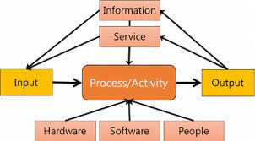

Figure 4: Physical Design Diagram

***Data Input:***

* **Client Inputs:** Clients enter travel preferences, search criteria, and booking details into the system through forms and search interfaces on the client portal.
* **Agent Inputs:** Travel agents input package details, availability, and pricing information into the system via the travel agent interface.

***Data Processing:***

* **Booking System:** Manages and processes booking requests, updating availability in real-time and handling payment transactions securely.

***Hardware Requirements:***

* **Server Infrastructure:** Requires reliable servers to host the application and manage data storage. These servers handle requests from clients and agents, run the backend services, and maintain database integrity.
* **Client Devices:** Users access the system through desktops or smartphones, requiring standard web browsers and internet connectivity

***Software Requirements:***

* **Web Server:** Runs the application and handles client-server interactions.
* **Database Management System:** Stores user data, travel packages, booking information, and transaction records.
* **Security Software:** Implements encryption and secure authentication methods to protect data and transactions.

# **CHAPTER 4: SYSTEM IMPLEMENTATION**

## **4.1 Code Generation**

***a) Identification of Tools and Resources***

The following tools and resources are identified for effective code generation:

Hardware Resources:

- *Laptop:* Lenovo X240 laptop

-*Storage:* 500 HDD

- *Processor:* Intel Core i5

-*RAM:* 8 GB

Software Resources:

- Integrated Development Environment (IDE): Mousepad

- Programming Languages: HTML, CSS, JavaScript, PHP

- Version Control System: GitHub

- Database: MYSQL

-OS: Ubuntu 20.04 LTS

-Web Browser: brave, mozilla firefox

***b) Actual Software Code Generation***

The actual code generation followed the technical specifications outlined in the design phase. The development team used the identified tools and resources to write, compile, and build the software solution. The code adhered to coding standards, best practices, and security considerations.

## **4.2 Software System Integration**

Software system integration involved bringing together the individual subsystems into a unified system. This phase ensured that all components worked cohesively. Key activities included:

- Integrating front-end and back-end components.

- Ensuring seamless communication between different modules.

- Addressing any dependencies and resolving integration issues.

- Verifying data consistency across the entire system.

### **4.2.1 User Interface**

***Home Page:*** *The Home Page is the initial point of access for users, offering a clear and intuitive interface to navigate the Travel Plan Manager. It features:*

* **User Login:** Provides login options for both clients and travel agents. This allows users to access their personalized accounts and manage their travel plans efficiently.
* **Navigation Links:** Includes links to key sections such as travel packages, booking management, and user profile settings.
* **Search Bar:** Enables clients to search for travel packages based on their preferences and criteria.

Here is an image of the Home Page:

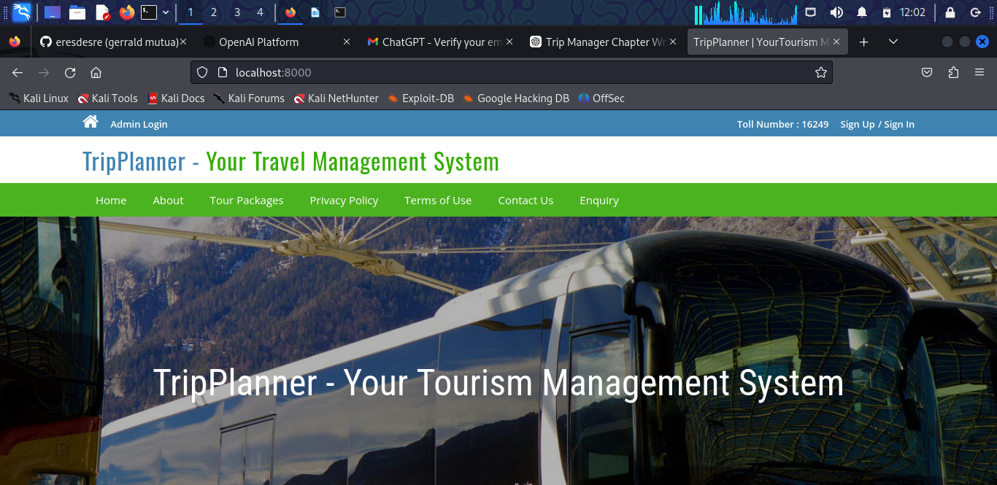

Figure 5: User Interface Diagram

*User Login*

The figure below showed the login form of a user so that they could be able to access the home page where they could request the packages they need.

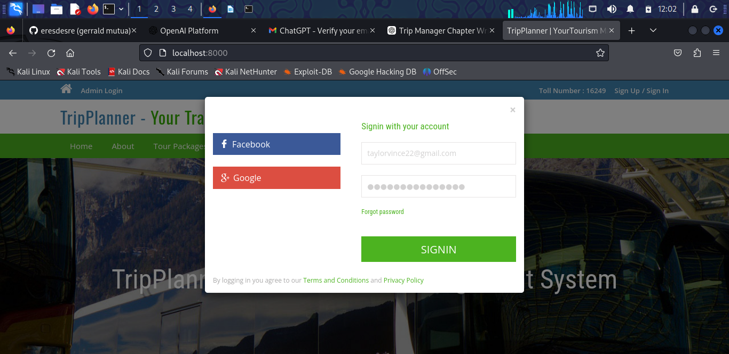

Figure 6: User Login Diagram

*User Registration Form:*

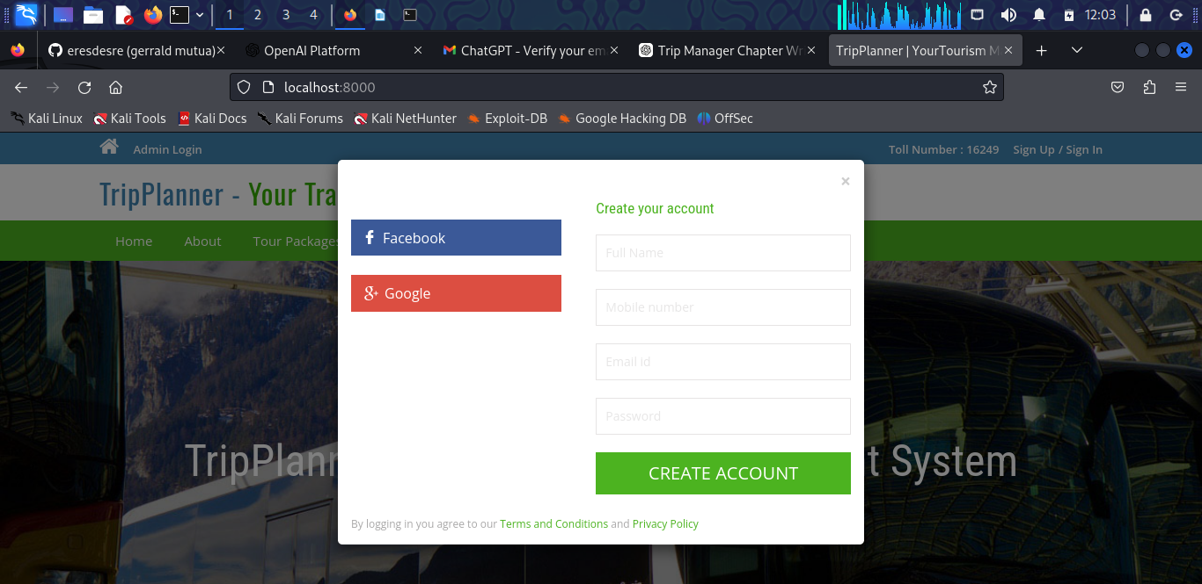

Figure 7: User Registration Form

The above image showed the registration form that users would use if they did not have an account so that they could be able to login once they came back later.

Here is an image displaying the packages section-

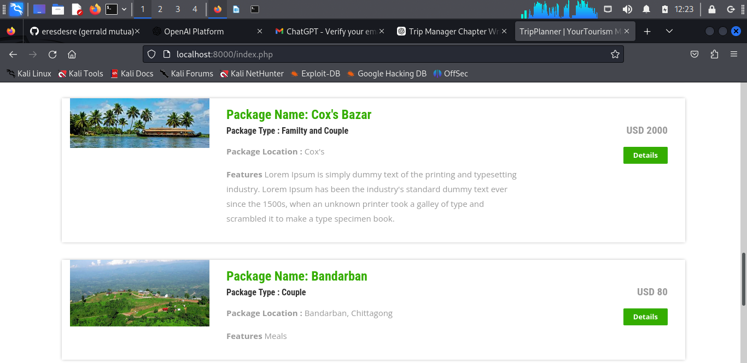

Figure 8: Service Diagram

*Order Service Form:*

Upon logging into the system, users are directed to the booking page where they can place tour requests or book travel packages. This form allows users to select their desired tour package, specify travel dates, and provide additional details such as preferences or special requirements.

The booking information is then transmitted to the tour operators' dashboard. Tour operators can view and manage incoming bookings, including details about the client, the chosen tour package, and the scheduled travel dates. This streamlined process ensures that both clients and operators can efficiently handle tour arrangements.

*Contact Us Form:*

The screenshot below shows the platform in which the users accessed so as to contact the tripplanner team and provide their concerns



Figure 9: Contact Us Page

### **4.2.2: Admin Access Services**

The Admin Dashboard serves as the central management hub for overseeing all aspects of the tour management system. Upon logging in, administrators are presented with a comprehensive overview of the system's operations. Key features include:

* **Dashboard Overview:** Displays a summary of system activities, including total bookings, pending requests, and recent user activity.
* **Booking Management:** Allows administrators to view and manage all tour bookings, including details of clients, travel dates, and package choices.
* **User Management:** Provides tools for managing user accounts, including adding new users, updating user information, and deactivating accounts.
* **Package Management:** Enables the administration of tour packages, including creating, updating, and deleting tour options.
* **Feedback and Contact Information:** Shows client feedback and messages submitted through the contact us page, facilitating communication and issue resolution.

*Admin login form:*

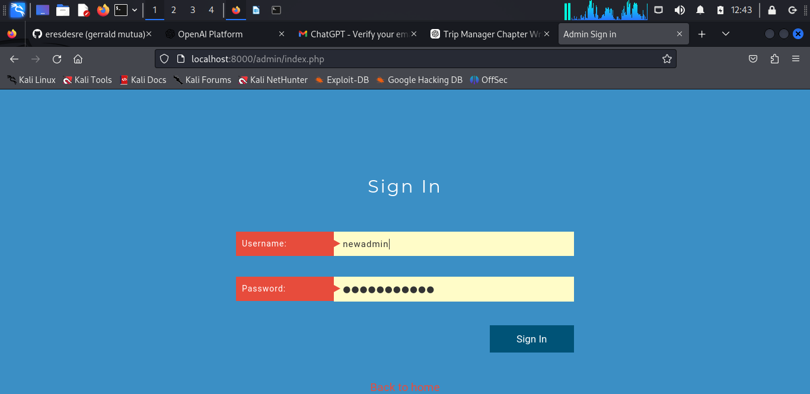

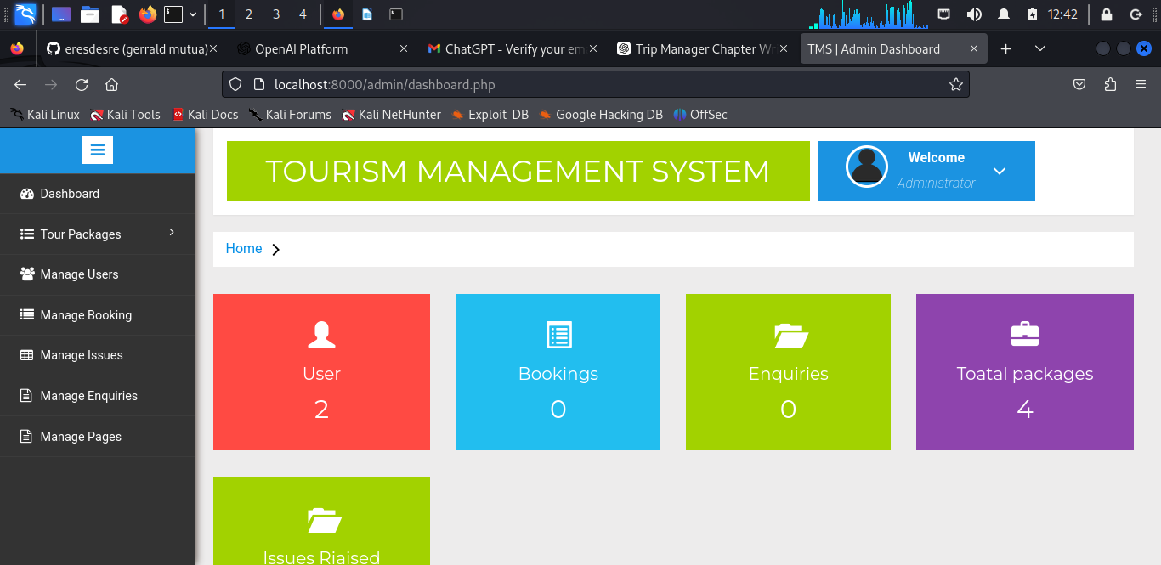

Figure 10:Admin Dashboard

### **4.2.3: Database Design**

The image below shows the database for a user that showed the users that are logged in to the system and their details-

*User Database:*

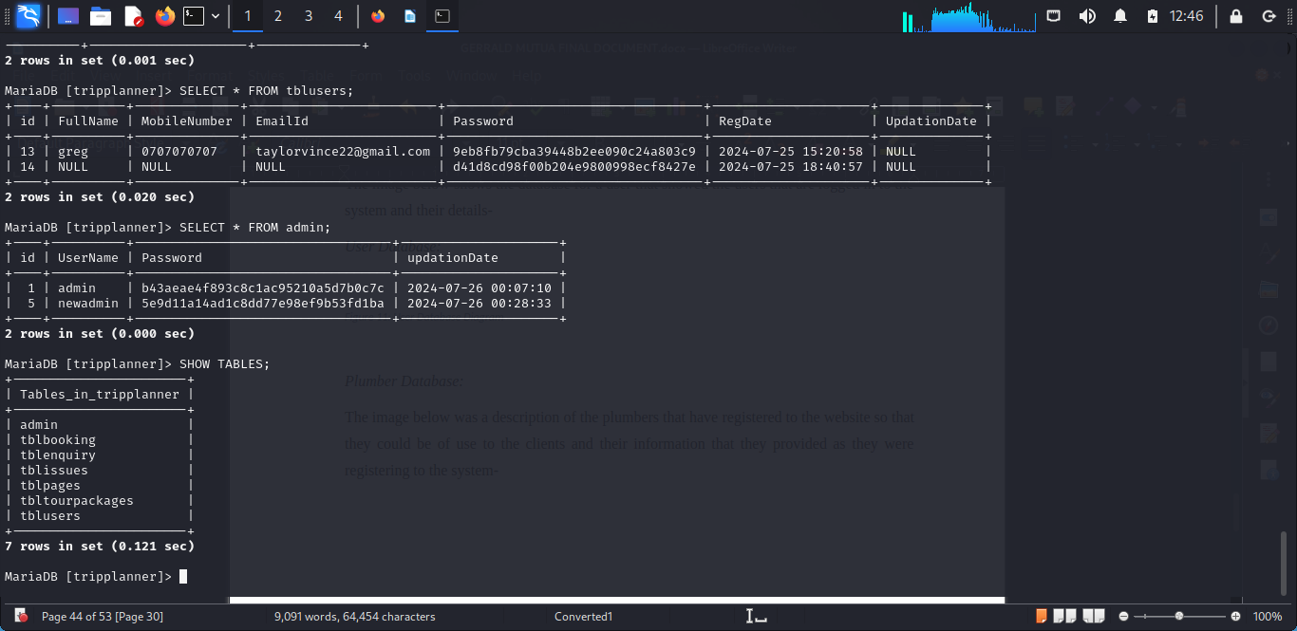

Figure 11: Database SCREENSHOT using the terminal interface instead of GUI

Figure 12: Orders Database

### **4.2.4: Entity Relationship Diagram**

An ERD visually represented the relationships between sets of entities stored in a database. In this, an element meant a data component. In essence, ERDs give a visual representation of the logical structure of databases. Here is an example of an ERD-

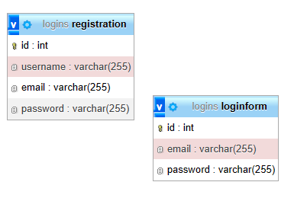

Table 1: ERD

## **4.3 Software System Testing**

Software testing was a critical aspect of system implementation, involving systematic checks that ensured correctness. The testing phase included the following components:

***Tour Booking:***

* **Objective:** Tested the effectiveness and accuracy of the tour booking process.
* **Test Case:** A user selected a tour package on the web platform and proceeded to book it.
* **Expected Result:** The booking was recorded in the system, assigned to the appropriate tour operator, and confirmed with a booking reference number sent to the user’s email.

**Client Inquiry:**

* **Objective:** Assessed the efficiency of client inquiries submitted through the contact us form.
* **Test Case:** A user submitted an inquiry about a tour package via the contact form on the website.
* **Expected Result:** The inquiry was captured in the system, categorized based on subject, and routed to the relevant admin or support team for follow-up.

**Unit Testing:**

* **Objective:** Verified individual components for accuracy.
* **Example:** Tested the tour booking module in isolation to ensure it correctly processed and recorded bookings.

**Integration Testing:**

* **Objective:** Ensured that integrated components functioned together seamlessly.
* **Example:** Tested the interactions between the tour booking, user management, and payment processing modules.

**System Testing:**

* **Objective:** Confirmed that the entire system met the specified requirements.
* **Example:** Conducted end-to-end testing from tour selection to booking confirmation to ensure the system operated as expected.

**c) Error Discovery**

**Identification:** Errors were identified through systematic execution of test cases and scenarios.

* **Prioritization:** Recorded errors were categorized based on severity and their impact on system functionality.

**d) Correctness Criteria**

**Usability:** Ensured the system was user-friendly and intuitive, allowing users to navigate and complete tasks with ease.

**Security:** Verified that communications were secure and user data was protected against unauthorized access.

**Performance:** The system was assessed for responsiveness, ensuring it quickly processed user actions and queries.

**Reliability:** Confirmed that the system operated smoothly without unexpected failures or breakdowns.

**Conclusion**

Comprehensive coding, integration, and testing of subsystems validated whether the system adhered to project goals and requirements. These methodologies, combined with systematic testing, contributed to developing a reliable tour management system. The subsequent diagrams illustrate examples and cases from the testing stages, showcasing the robustness of the system.

# **CHAPTER 5: CONCLUSION AND RECOMMENDATIONS**

## **5.1 Conclusion**

The development and deployment of the Tour Management System (TMS) marked a significant advancement in addressing the complexities of traditional travel planning and management. The systematic analysis, design, and implementation phases resulted in a comprehensive digital platform that aimed to enhance the travel experience for both clients and service providers.

**Key Achievements:**

* **Streamlined Tour Booking:** TMS introduced a user-friendly interface for seamless tour booking, enabling clients to select, book, and manage their travel plans with ease.
* **Real-Time Availability:** The system's real-time updating capability allowed users to view and book available tours and accommodations instantly, reducing waiting times and improving overall efficiency.
* **Transparent Pricing:** Clear and detailed pricing information ensured users could make informed decisions, enhancing trust and satisfaction in the booking process.
* **Secure Communication:** The platform facilitated secure and efficient communication between clients and travel agents, ensuring privacy and reliability in all interactions.

**5.2 Recommendations**

While the TMS achieved significant milestones, ongoing improvements will be essential to adapt to evolving user needs and technological advancements. Recommendations for future enhancements include:

* **User Feedback Mechanism:** Implementing a robust feedback system to gather insights on user experiences. Regularly reviewing this feedback to identify areas for improvement and to refine the system accordingly.
* **Integration with Payment Systems:** Adding secure and convenient payment options directly within the platform to streamline transactions and offer a more comprehensive end-to-end travel booking experience.
* **Mobile Application Development:** Developing standalone mobile applications for iOS and Android devices to provide users with more accessible and on-the-go access to the TMS functionalities.
* **Enhanced Data Analytics:** Leveraging advanced data analytics to analyze user interactions, booking patterns, and feedback. These insights can drive future improvements and strategic planning for system upgrades and expansions.

**5.3 The Prototype for a Second System**

The TMS not only addresses current challenges but also sets a precedent for future innovations in travel management systems. As technology and user expectations continue to evolve, the TMS will serve as a foundation for further development and adaptation. We anticipate that the prototype will influence industry standards and potentially pave the way for new solutions that prioritize efficiency and user experience.

The TMS exemplifies the potential for digital transformation in travel services, emphasizing a blend of technological advancement and user-centric design. By implementing the suggested improvements and maintaining a commitment to innovation, the TMS could significantly impact the travel industry, setting new benchmarks for service quality and operational efficiency.

# **REFERENCES:**

**1. Jansen, K., & Roesler, M. (2020).** The Evolution of Digital Platforms in the Travel and Tourism Industry. International Journal of Tourism Research, 22(1), 59-74.

* + Discusses the impact of digital platforms on the travel and tourism industry, including system design and user experience improvements.

1. **Pereira, R. S., & Mendes, M. J. (2019).** Innovations in Travel Management Systems: A Case Study. Journal of Travel Research and Management, 31(2), 112-130.
   * Analyzes advancements in travel management systems and their implications for the travel industry.
2. **Khan, A. S., & Ahmed, N. (2021).** Leveraging Mobile Technology for Enhanced Travel Management. Proceedings of the International Conference on Travel and Tourism Technology, 65-79.
   * Examines the role of mobile technology in improving the efficiency and user experience of travel management systems.
3. **Williams, R., & Carter, J. (2020).** User Experience Design in Travel and Tourism Platforms: Trends and Insights. Journal of Hospitality and Tourism Technology, 11(4), 345-359.
   * Provides insights into user-centric design trends and their application in travel and tourism platforms.
4. **Singh, P., & Gupta, A. (2019).** Integration of Payment Systems in Travel Management Platforms. International Journal of E-Commerce and Digital Marketing, 15(3), 223-237.
   * Focuses on the integration of payment systems within travel management platforms to enhance user convenience and security.